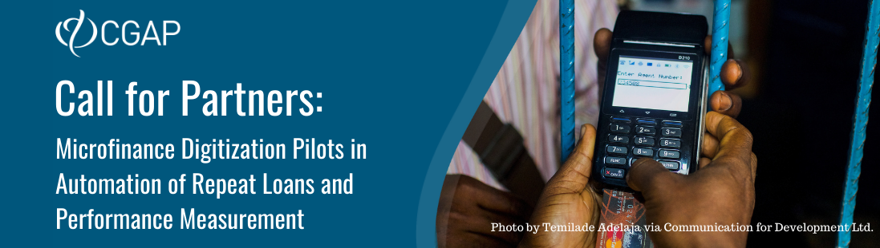

Expression of Interest
You are applying for:
- Measurement Workstream: Yes/No b. Automation Workstream: Yes/No c. Both: Yes/No
SECTION I. About Your Organization
1 | Full name of organization | >>
2 | Website | >>
3 | Name of CEO | >>
4 | Email address of CEO | >>
5 | Contact person at your organization  (CGAP counterpart responsible for the project) | Name | >>
 |  | Title | >>
 |  | Business unit (if applicable) | >>
 |  | Role  (Max. 50 words) | >>
 |  | Phone number | >>
 |  | Email address | >>
6 | Year the organization started operations | >>
7 | Type of license (type of license held in the concerned markets, e.g., microfinance provider, payments service bank, other) (Max. 100 words)
 | >>
8 | Description of the organization and the core product / service offering of the applying business unit, including key product features, total # of customers using the product, and their demographic profile, geographic reach, market share and any other data you deem relevant) (Max. 100 words)
 | >>
9 | Briefly describe the roles and responsibilities of key staff that would be involved in the project (Max. 200 words)
 | >>
10 | Name of implementing partners (if any) and their role in the organization’s efforts to participate in this project (Max. 200 words)
 | >>

SECTION II. Minimum Selection Criteria
1 | Illustrate the willingness and ability of staff to lead and execute the project (Max. 200 words)
 | >>
2 | If your organization is present in multiple countries, confirm where the product concerned is being offered. Include any other geographical considerations (e.g. specific focus regions within a country, or country expansion plans)  (Max. 100 words)
 | >>
3 | Describe your data extraction and warehousing processes (Max. 200 words)
 | >>
4 | Describe your data analysis tools (e.g., tableau, Power BI, Python) (Max. 200 words)
 | >>
5 | What is your timeline for the project? Include, at a minimum, your preferred project kickoff date, and proposed timeline from project kickoff to product launch. (Max. 100 words)
 | >>
6 | What are the main challenges (internal or external) you foresee to the success of the planned initiative? How do you plan to mitigate these? (Max. 150 words)
 | >>
SECTION III. Organization Commitment
1 | Please provide the name and title of the key project sponsor (preferably at the C-level) within the applicant organization and any partners, and confirm their willingness to provide a letter of commitment for the organization should this application be selected. Please also provide the name of the person inside the applicant organization who is able to dedicate at least 50 percent of his or her time to this project for its duration, and mention any other resources your organization will dedicate to this project (financial, human, other).  (Max. 100 words)
 | >>
2 | Confirm willingness to share non-sensitive information during and after the implementation, including related to product take-up, impact, challenges, key success factors and lessons learned during the project. CGAP will not disclose information without the consent of the partners and would not publish or disclose sensitive competitive information.
 | >> Yes / No (delete that which is not relevant)
3 | Confirm willingness to participate in CGAP's Community of Practice during and after the project implementation.
 | >> Yes / No (delete that which is not relevant)
SECTION IV.a Specific Requirements – Measurement Workstream
1 | Describe the finalized and/or well-advanced digitization initiative(s) results you would like to measure under this project if not covered under Section I (8) (Max. 400 words)
 | >>
2 | Confirm that you will be ready to share (access to) data and start the measurement work within a month after being selected. Please illustrate. (Max. 100 words)
 | >> Yes / No (delete that which is not relevant)
SECTION IV.b Specific Requirements – Automation Workstream
1 | Confirm that you will be ready to start the pilot of repeat loans credit automation within three months from being selected. Please illustrate. (Max. 100 words)
SECTION V. Additional Information
1 | Is there any additional information you would like to provide? (Max. 200 words)
 | >>
Deadline for submission is November 15, 2021.
- The announcement of the call for EOIs contains links to the EOI form and other documents for this project.
-Please submit any questions and/or your completed expression of interest to Ivo Jenik at ijenik@worldbank.org.

If different from CGAP counterpart mentioned on page 1

