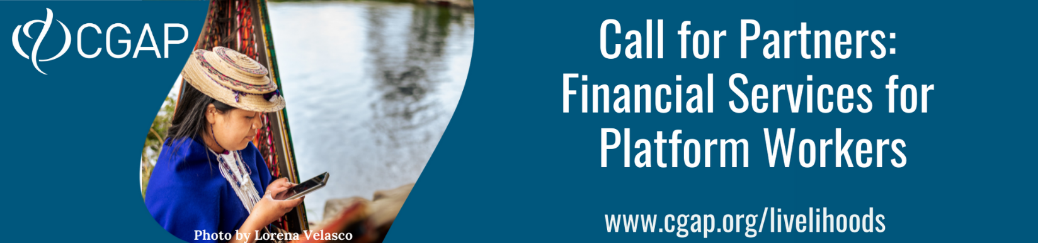

Expression of Interest
SECTION I. About Your Organization
1 | Full name of organization | >>
2 | Website | >>
3 | Name of CEO | >>
4 | Email address of CEO | >>
5 | Contact person at your organization  (CGAP counterpart responsible for the project) | Name | >>
 |  | Title | >>
 |  | Business unit (if applicable) | >>
 |  | Role  (Max. 50 words) | >>
 |  | Phone number | >>
 |  | Email address | >>
6 | Year the organization started operations | >>
7 | Type of organization (e.g. home-services, ride-hailing, e-commerce, e-lancing or delivery platform; Fintech; bank; insurer; other (please specify) (Max. 100 words)
 | >>
8 | Description of the organization and the core product / service offering of the applying business unit, including total and active # of workers / sellers (disaggregated by gender; please specify period of activity for workers, e.g. last 30 days). Please also supply any other data that can help illustrate your scale of operation and market positioning, e.g. number of customers; geographic reach; market share; target segment/s etc.) (Max. 100 words)
 | >>
9 | Briefly describe the roles and responsibilities of key staff that would be involved in the project (Max. 200 words)
 | >>
10 | Name of implementing partners (if any) and their role in the organization’s efforts to deliver financial services to platform workers. If your organization is not a platform, describe the nature of the platform committed to partnering with you (Max. 200 words)
 | >>
SECTION II. About your Strategy for Delivering Financial Services to Platform Workers
1 | Does your organization currently deliver, or enable, financial services to platform workers? If so, please describe the nature of those financial services, the take up, and the current successes and challenges.  If your organization is not yet offering financial services to platform workers, describe the key impediments to offering financial services, and how far away you are from addressing those. (Max. 300 words)
 | >>
2 | Describe the type of financial service, and associated features, that would be the focus of the CGAP-supported project. Explain how this product will enhance the livelihood of platform workers/sellers, including the specific type of platform workers/sellers this product will target and describe any gender considerations. (Max. 300 words)
 | >>
3 | Describe why your business wants to deliver, or enable the delivery of, financial services to platform workers. What are your strategic priorities and how does this fit into your strategy? What business challenges or opportunities for your platform do you see this addressing or taking advantage of (if multiple reasons, please highlight priorities)? How will success be measured (KPIs)? (Max. 300 words)
 | >>
4 | If your organization is present in multiple countries, confirm where this product will be launched. Include any other geographical considerations (e.g. specific focus regions within a country, or country expansion plans)  (Max. 100 words)
 | >>
5 | Describe the nature of the CGAP support the organization is seeking. This can be at a high level (e.g., product design, product management, product testing, data analytics, other) or can be more detailed if the organization has a specific need. Include your expected investment in this project, by partner. (Max. 200 words)
 | >>
6 | What is your timeline for the project? Include, at a minimum, your preferred project kickoff date, and proposed timeline from project kickoff to product launch. CGAP has a preference for projects that are planning product launch within 6-9 months from the project kick-off date, although are open to slightly longer duration and favor realistic plans. (Max. 100 words)
 | >>
7 | What are the main challenges (internal or external) you foresee to the success of the planned initiative (launch and take-up of the new/enhanced product or service) within the next 6-9 months? How do you plan to mitigate these? (Max. 150 words)
 | >>
SECTION III. Organization Commitment
1 | Please provide the name and title of the key project sponsor (preferably at the C-level) within the applicant organization and any partners, and confirm their willingness to provide a letter of commitment for the organization should this application be selected. Please also provide the name of the person inside the applicant organization who is able to dedicate at least 50 percent of his or her time to this project for its duration, and mention any other resources your organization will dedicate to this project (financial, human, other).  If your organization is not a platform, include (or attach) evidence of the commitment of a suitable platform, including the name and contact details of the key counterpart at the platform. (Max. 100 words)
 | >>
2 | Confirm willingness to share non-sensitive information during and after the implementation, including related to product take-up, impact, challenges, key success factors and lessons learned during the project. CGAP will not disclose information without the consent of the partners and would not publish or disclose sensitive competitive information.
 | >> Yes / No (delete that which is not relevant)
SECTION IV. Additional Information
1 | Is there any additional information you would like to provide? (Max. 200 words)
 | >>
Deadline for submission is October 15, 2021.
-The website www.cgap.org/livelihoods contains the complete set of documents for this project.
-Please submit any questions and/or your completed expression of interest to Rani Deshpande at gdeshpande@worldbank.org.

If different from CGAP counterpart mentioned on page 1

